**Mohammed mahin ibnay mamun / 23643001**

I started off by creating a folder and making an index.html file. I opened this file on visual studio code and Microsoft edge. As I completed all the lab tasks and have some experience in web development, I found this task easy. However, there were areas which I found hard, so I referred to w3schools for help.

I began by adding the base template

<!DOCTYPE html>  
<html lang="en">  
 <head>  
 <meta charset="UTF-8">  
 <title>My Website</title>  
 <link rel="stylesheet" href="./style.css">  
 </head>  
 <body>  
 <main>  
 <h1>Welcome to My Website</h1>   
 </main>  
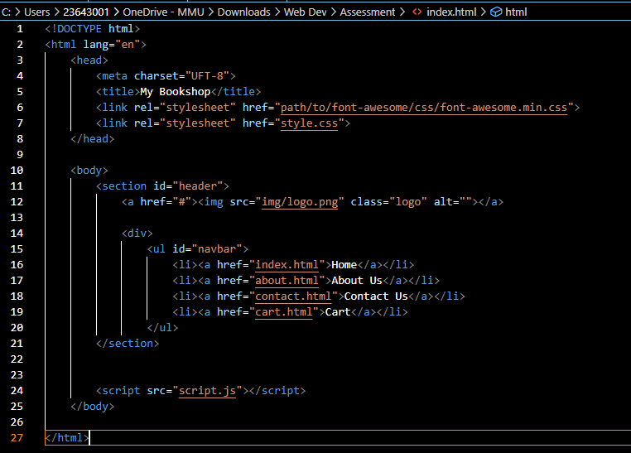

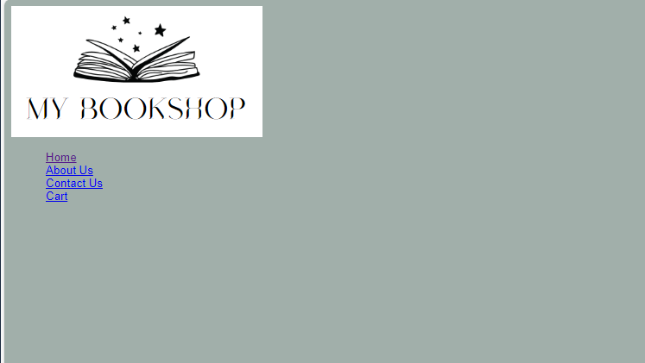

I found a logo online and began creating a list which I could use for my navigation bar. The code consisted of using lists which are linked to my html files. I also made a folder for my images.

Below shows the screenshot of the code I developed to move the navigation bar. This code is in the CSS style file.

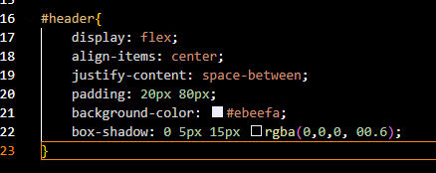

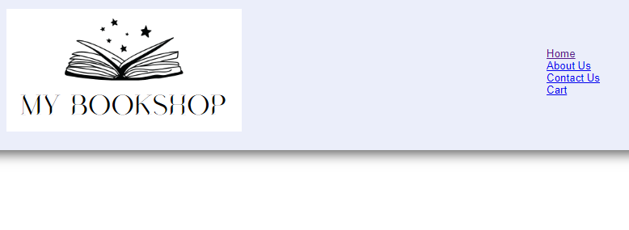

Added this code to remove bullet points and make the list vertical. Also used active so it is clear which page is being viewed.

* I created a flex container for the **#header** element, aligning the items vertically.
* Sets padding of **20px** on top and bottom, and **80px** on the left and right.
* I applied a light background color (**#ebeefa**) to the header.
* I added a box shadow effect.

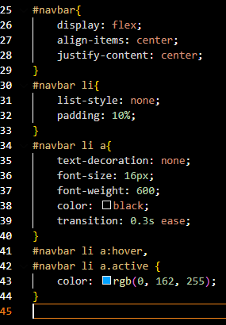



- I've used `display: flex` to make the navbar horizontally.

- With align-items: center and justify-content: center the items are centered vertically and horizontally within the navbar.

- my list items (`#navbar li`) have no bullet points (`list-style: none`) and have padding of `5%` to create spacing between them.

- I applied a transition effect.

- When hovering over anchor tags (`#navbar li a:hover`) or when an anchor tag is active (`#navbar li a.active`), the color changes to a light blue. I will add this on each document later, so it is easier for the user to notice which page they are on.

I imply added some text and created a new section for this on index.html

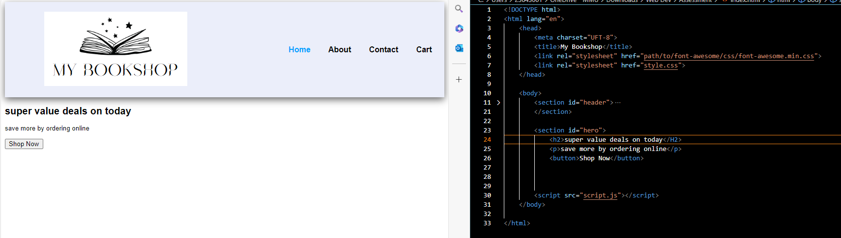

I resized and organized the layout of my website. I did this by resizing the logo and others then saving them in the `images/features` directory folder. Furthermore, I included this image in the `index.html` file and applied the `section-p1` class from the stylesheet CSS file which I made.

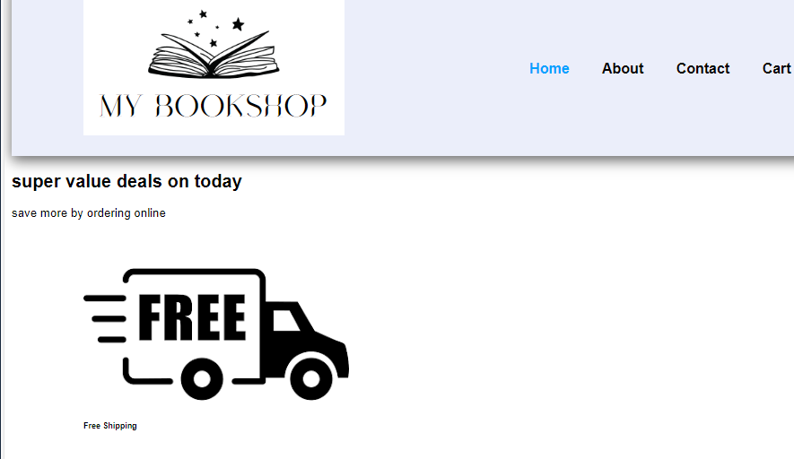

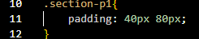

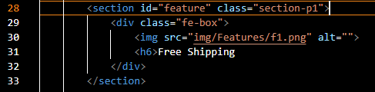

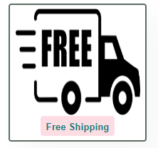

<section id="feature" class="section-p1">

<div class="fe-box">

<img src="img/Features/f1.png" alt="" width="175" height="150">

<h4>Free Shipping</h4>

</div>

<div class="fe-box">

<img src="img/Features/f2.png" alt="" width="175" height="150">

<h4>Order Online</h4>

</div>

<div class="fe-box">

<img src="img/Features/f3.png" alt="" width="175" height="150">

<h4>Save Money</h4>

</div>

</section>

On my index.html /homepage code, I've created a section with the ID "feature" and assigned it the class "section-p1". Within this section, I've added three div elements with the class "fe-box". Each div contains an image and a heading (h4) element.

- The images are sourced from the "img/Features" directory, and I specified the width height to make sure they are not too big or small.

- Each image represents a feature, I included the three: "Free Shipping", "Order Online", and "Save Money".

This structure allows for the display of key features with associated images on the webpage, it will make the website look nicer and more friendly to users.

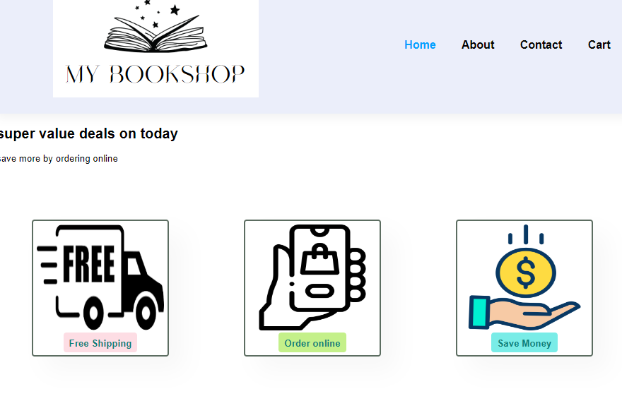

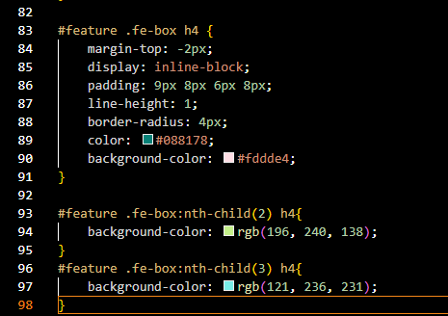

In the CSS file, I added some color and others, shown in the screenshot of my code above. This is not needed but it just makes the website more appealing to users.

- #feature .fe-box h4: This line of code targets all h4 elements inside .fe-box within #feature.

- margin-top: -2px; I used this to set a negative margin to adjust the positioning of the heading as it was abit higher than I wanted.

- display: inline-block; This line makes the heading display as an inline block to allow for padding and background color.

- padding: 9px 8px 6px 8px: I Specifies the padding around the heading content to make it look neat.

- line-height; 1: I set the line height to 1 for better vertical alignment.

- border-radius: 4px; I wanted a rounded border so used this.

- color: #088178; Sets the text color.

- background-color: #fddde4; Sets the background color of the heading.

- `#feature .fe-box:nth-child(2) h4`: Targets the second h4 element inside .fe-box within #feature. This is the second feature on my website

- `background-color: rgb(196, 240, 138); `: Sets a specific background color for the second feature.

- `#feature .fe-box:nth-child(3) h4`: Targets the third h4 element inside .fe-box within #feature. This is the third feature box.

- background-color: rgb(121, 236, 231); I set a specific background color for the third feature.

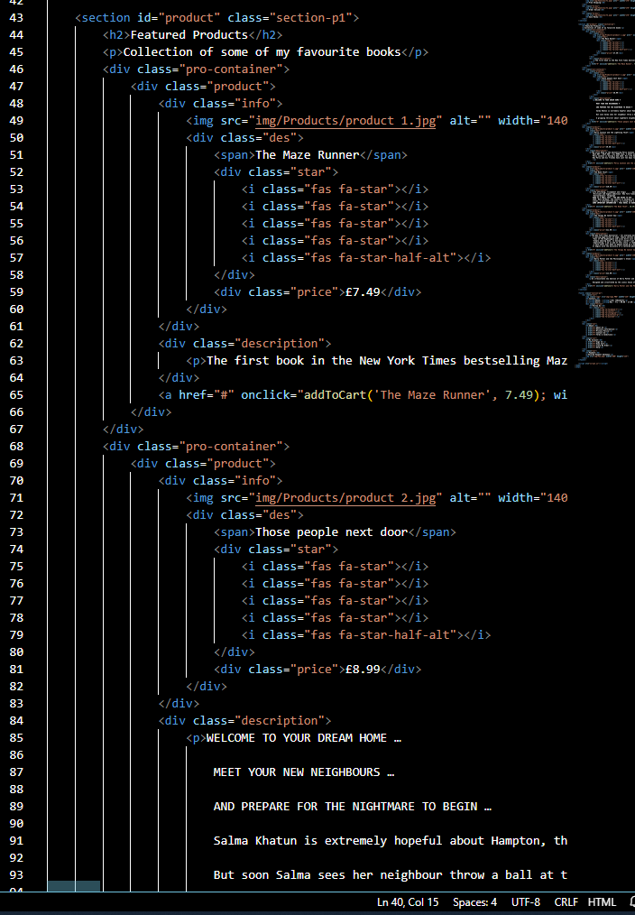

I then added code, this part was very simple, I started by creating a class product. Then I used an online website [Font Awesome Icons](https://fontawesome.com/v4/icons/) to let me add icons onto my own website. I used the star icon to add rating of my products on my website, I also used an icon for the cart and buy now button. Below is a screenshot of how my first attempt turned out.

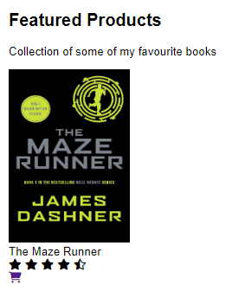

As you can see in the screen which I proved above, I added an image of a book, the title, ratings and a shopping icon. I copied and pasted this code 5 more times and changed the image and title.

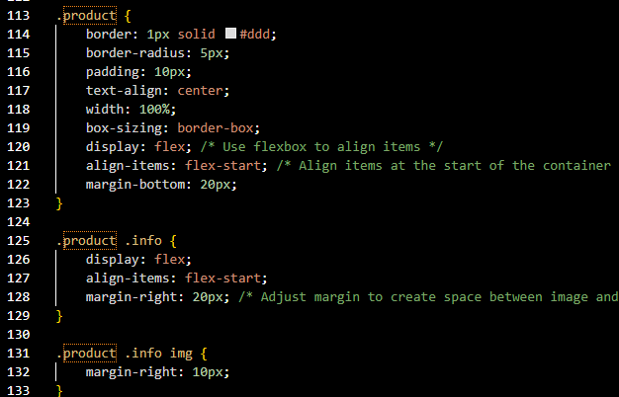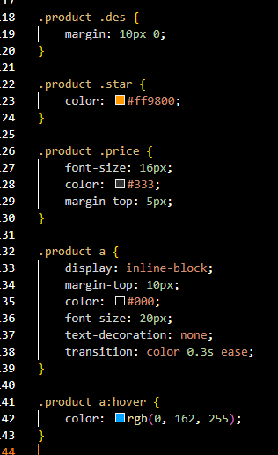

I also added to the css so it looks more suitable for sale. I made a borderline around each product and added a price and a buy now button.

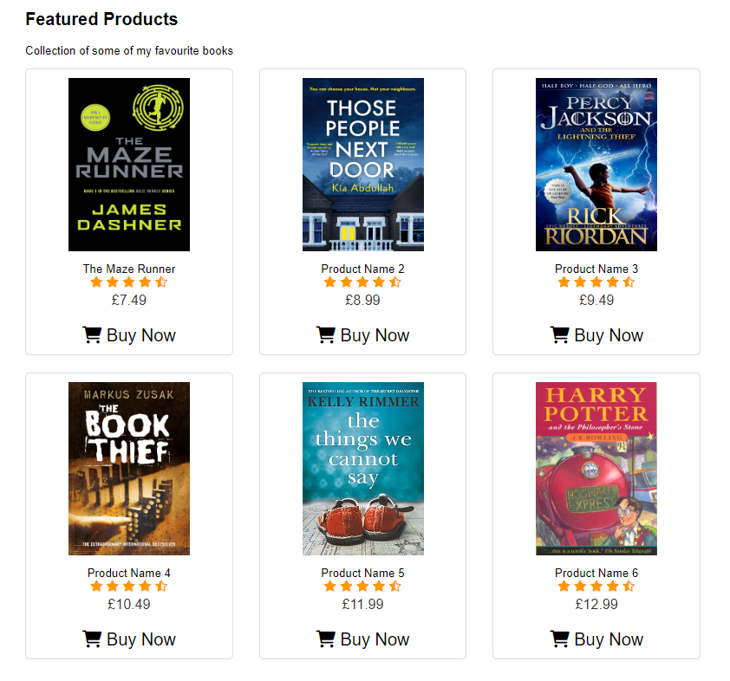

I then started developing a footer for my website. This code was copied and pasted onto my other pages. One again I used icons from the website I linked above.

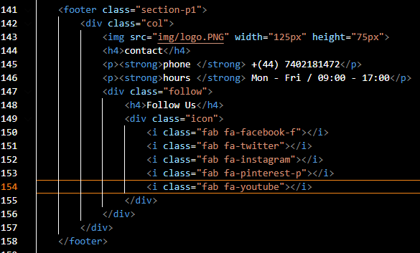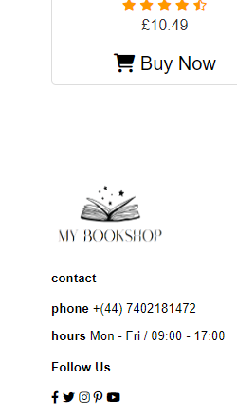

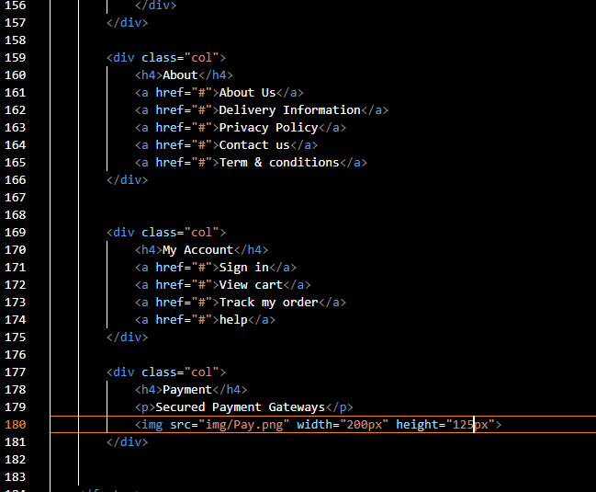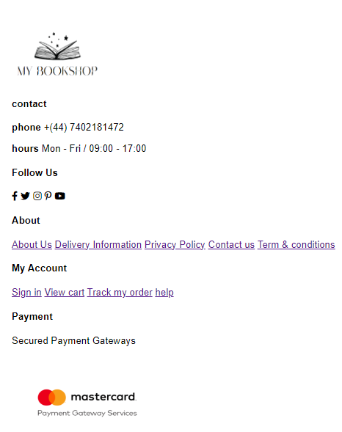

As you can see from my above, my footer was complete however it wasn’t in rows. I made some changes to the CSS file and was able to create a better layout.

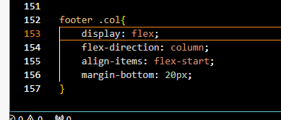

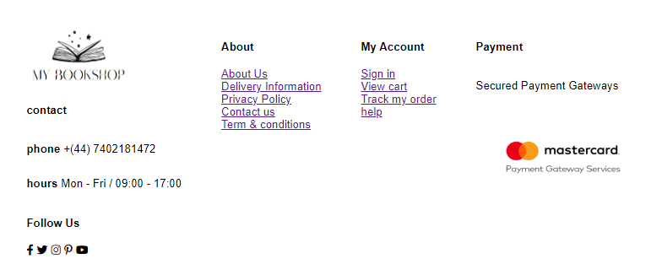

Now the footer has rows and is accessible for the user. It also looks much better.

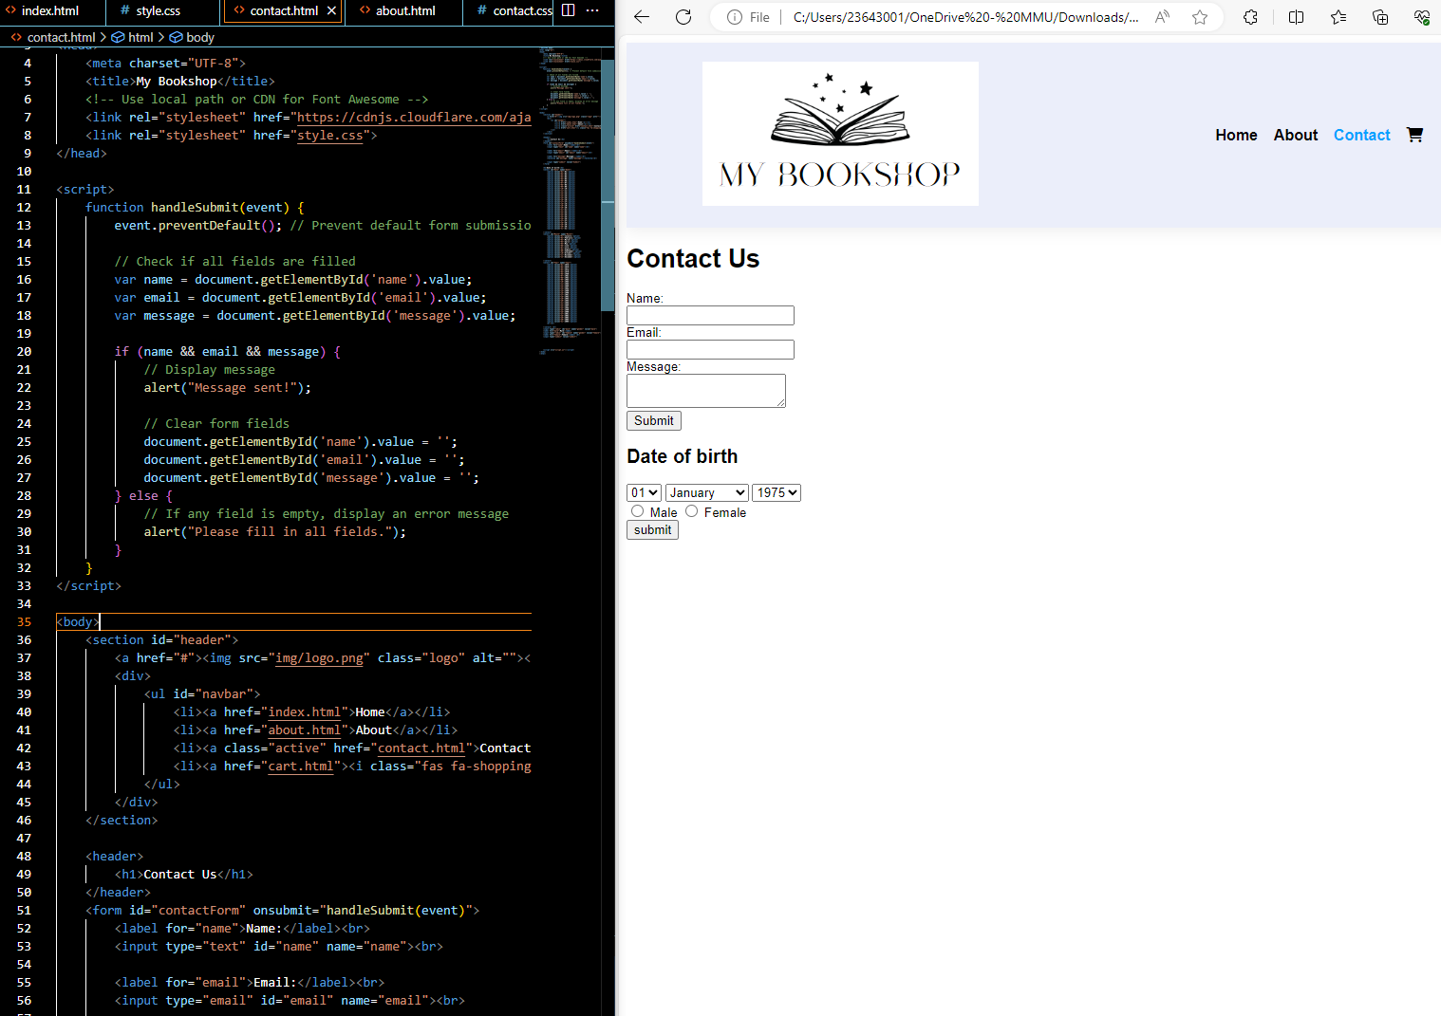I then created a html file for the contact us page. I used a form which I had saved from one of the first week's lab exercises.

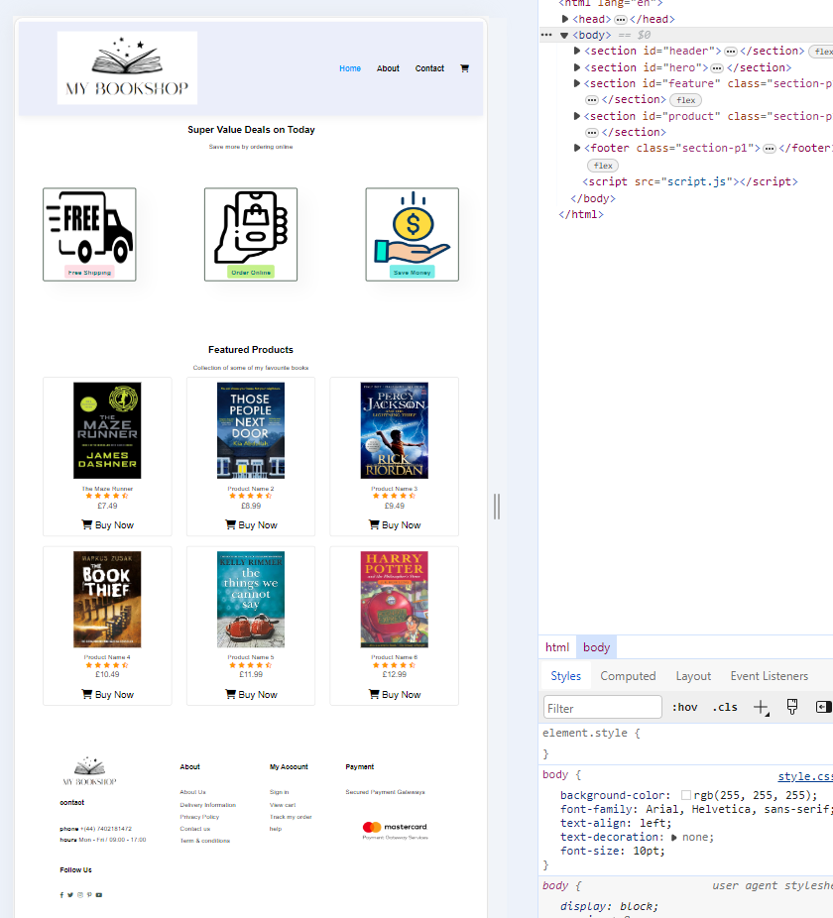

I went into inspect element on my website and toggled to the mobile and tablet option to see if everything was okay and if anything needed amending.

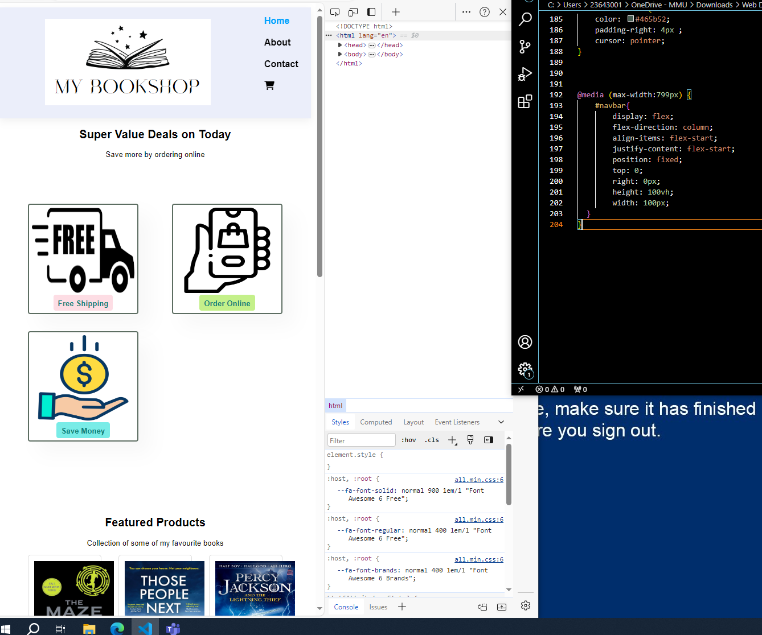Here is an image of the mobile version. As you can see, the navigation bar is now vertical as it won't all fit if i kept it horizontal. To make this change I just needed to use the display: flex and a few others in the CSS file.

**Final design home page**

Below are a few screenshots of my homepage. It includes

* A working navigation bar
* A logo, some
* About my website features
* 6 Products
* Ratings
* Titles
* footer

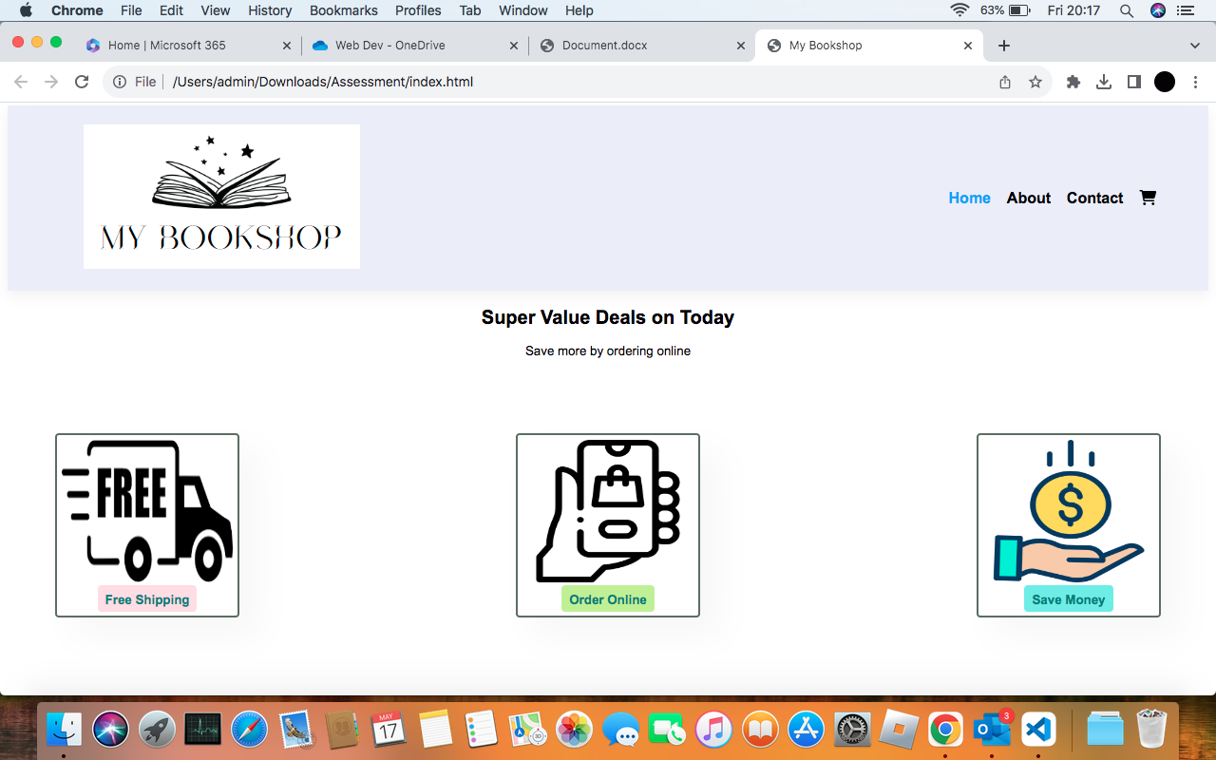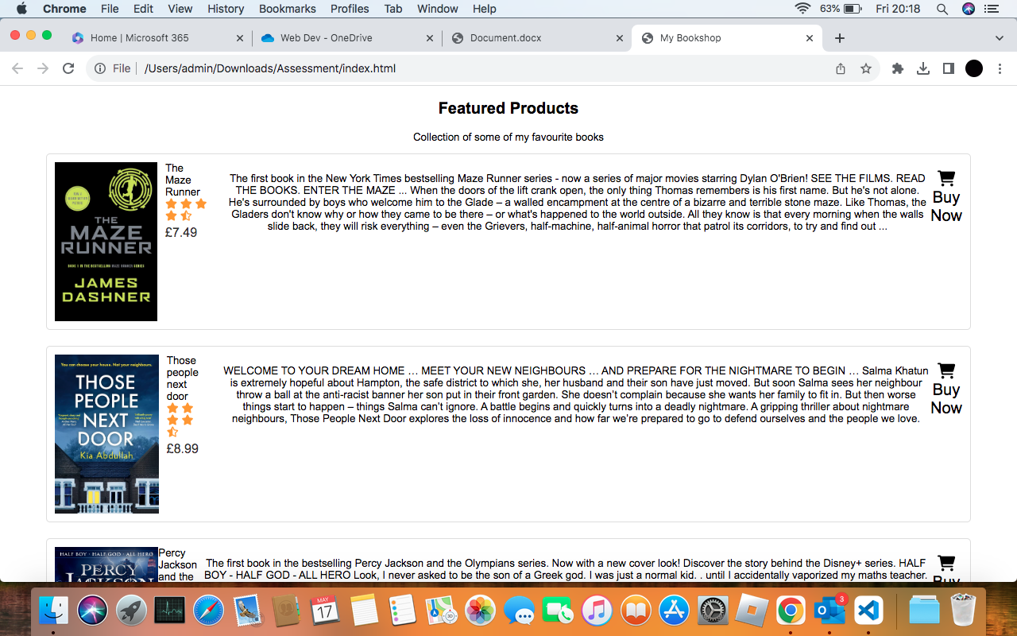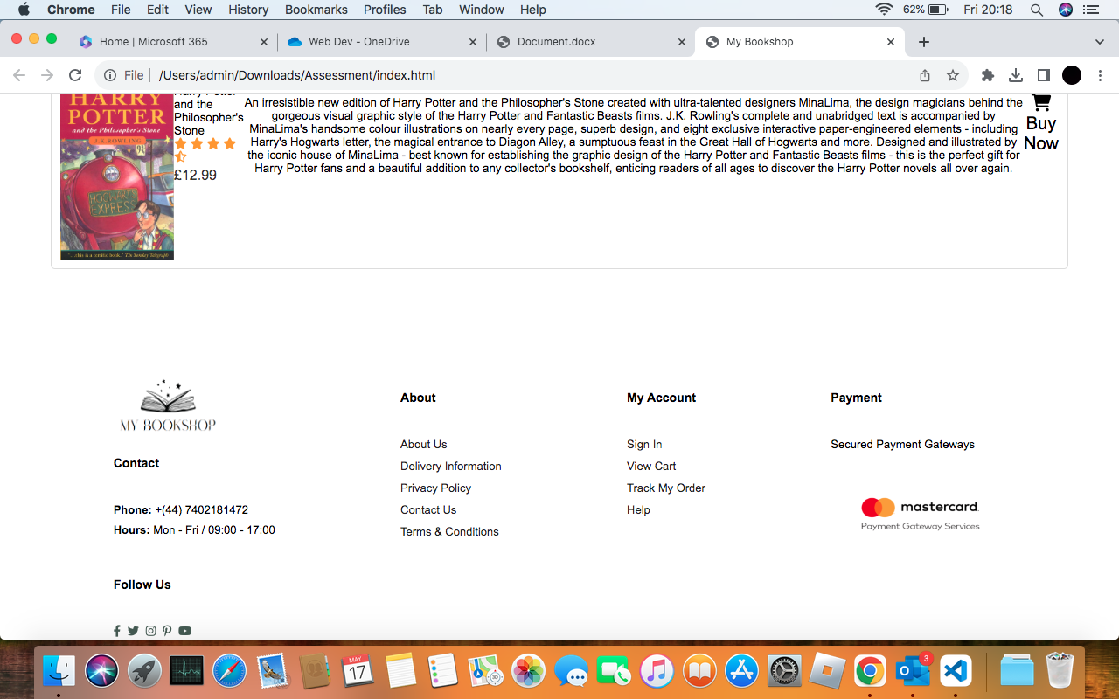

**Final design about page**

I left this page out, as I wanted to focus on the other areas first and the harder parts. This page is accessible for users with a coming soon message. In future a will add some paragraphs on this page and maybe images.

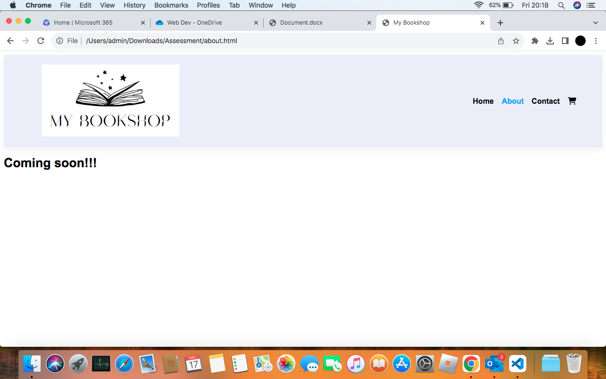

**Final design contact page**

This page was very straight forward to create, in the first few weeks of the labs, I was taught how to create multiple different forms.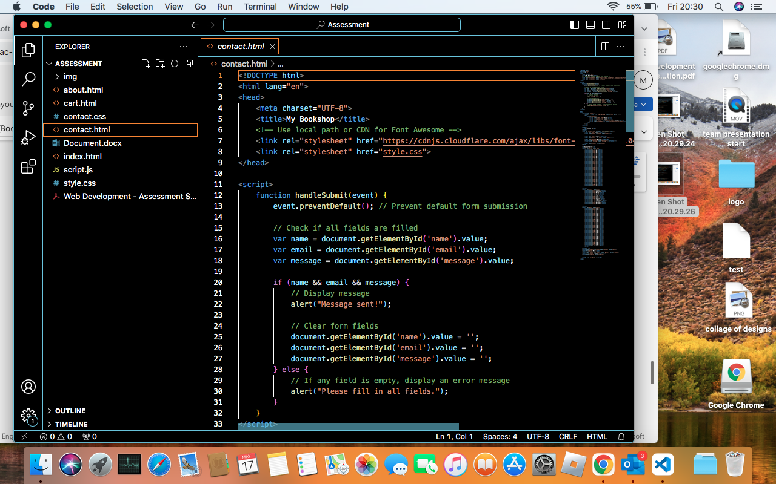

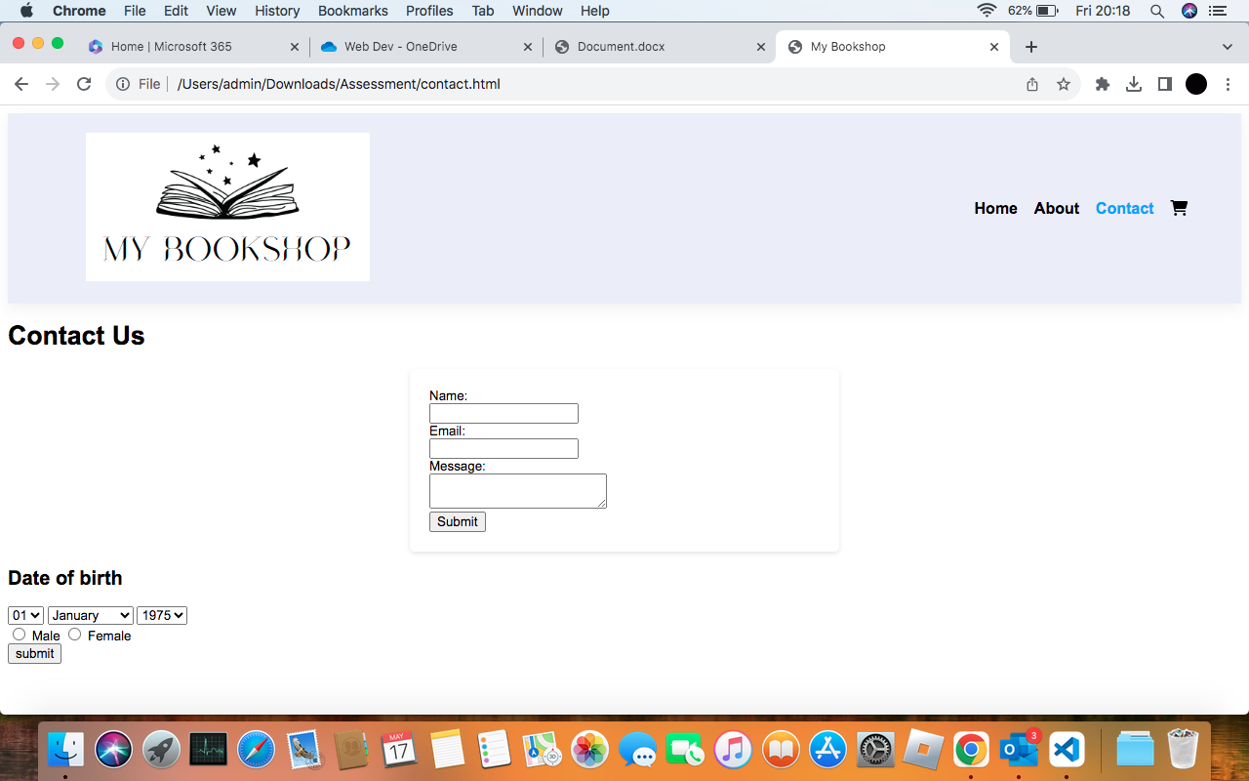

**Final design cart page**

This page took the most time to create, it required JavaScript in order to work. Designing was simple, I just made a list in the style of a table and alligned text below them. I struggled on making the total add up, however after independent research I managed to fix this.

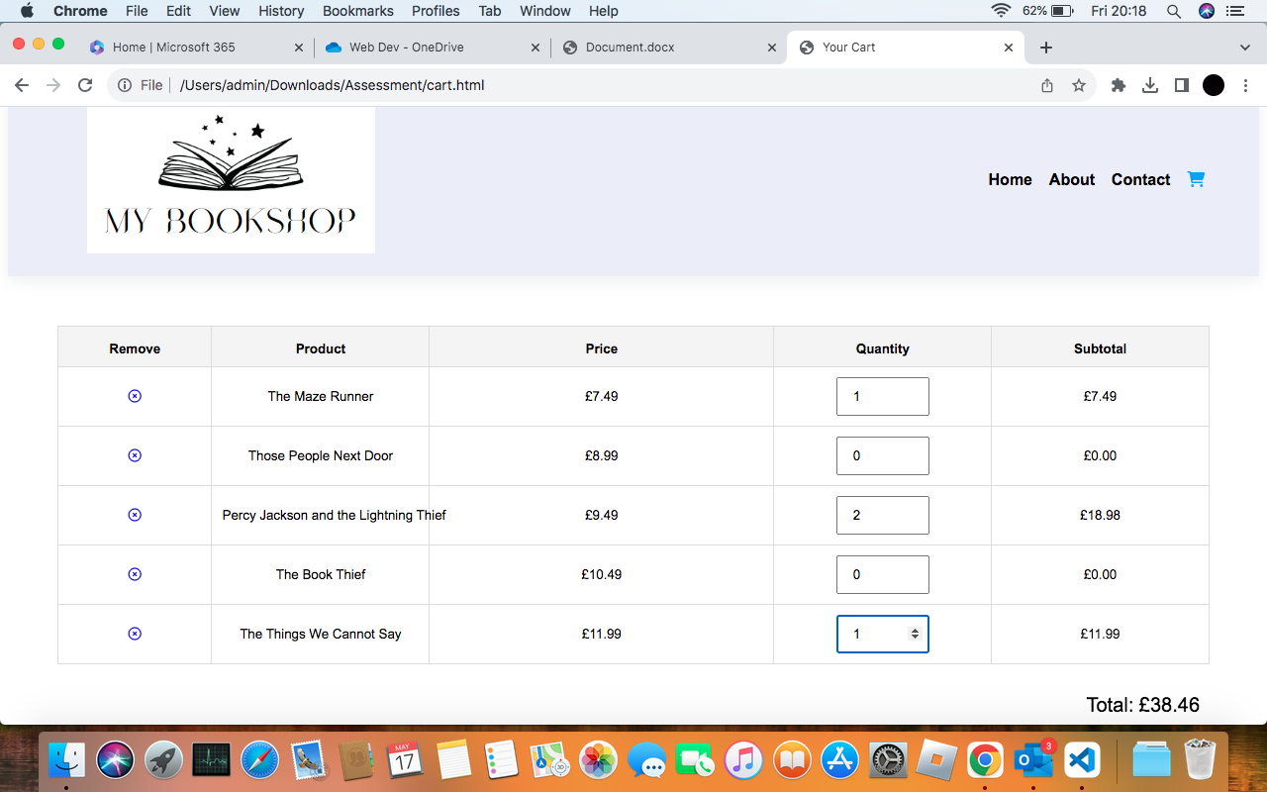

I had some experience with getting prompts to appear, the programming for this part was more fun than the design. 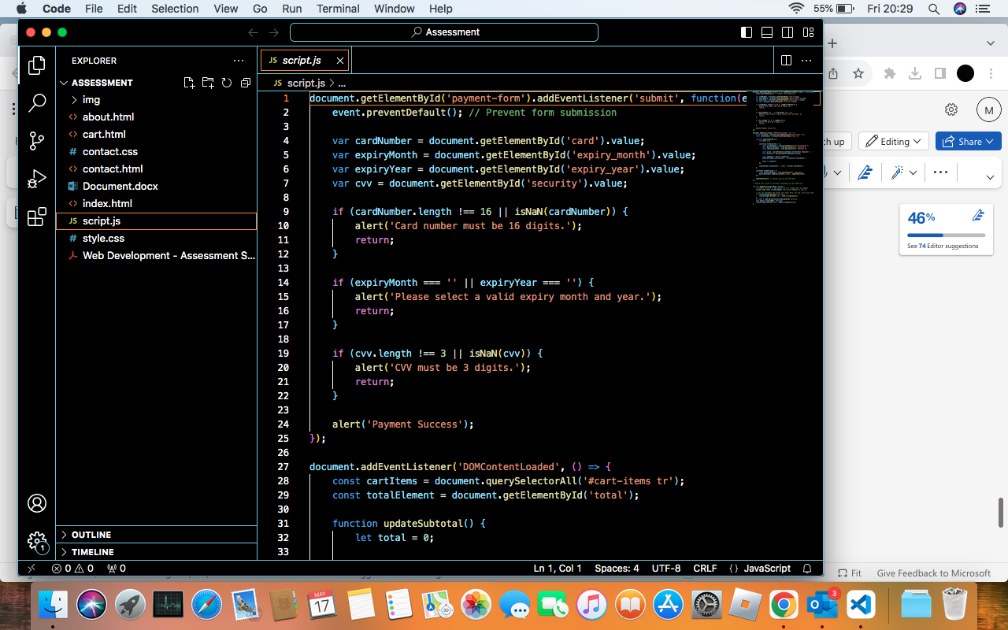the full code is available through the script.js file. I found it very similar to python and a few other coding languages which I have used before.

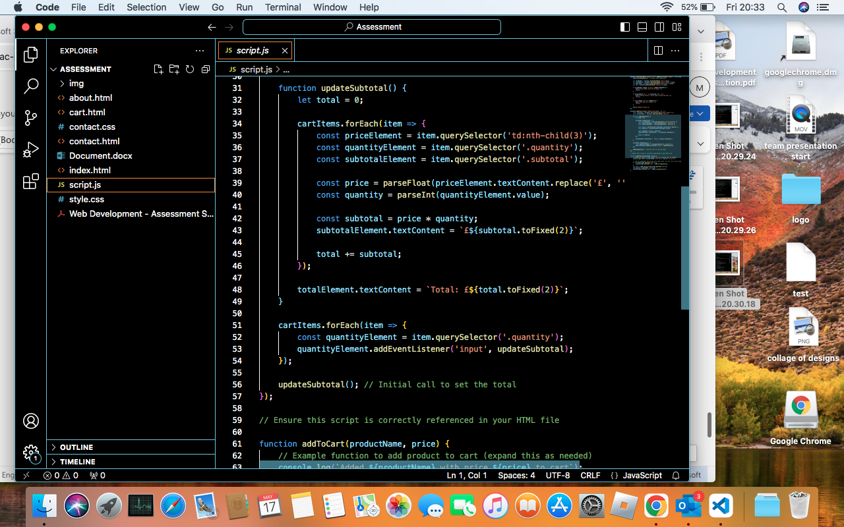

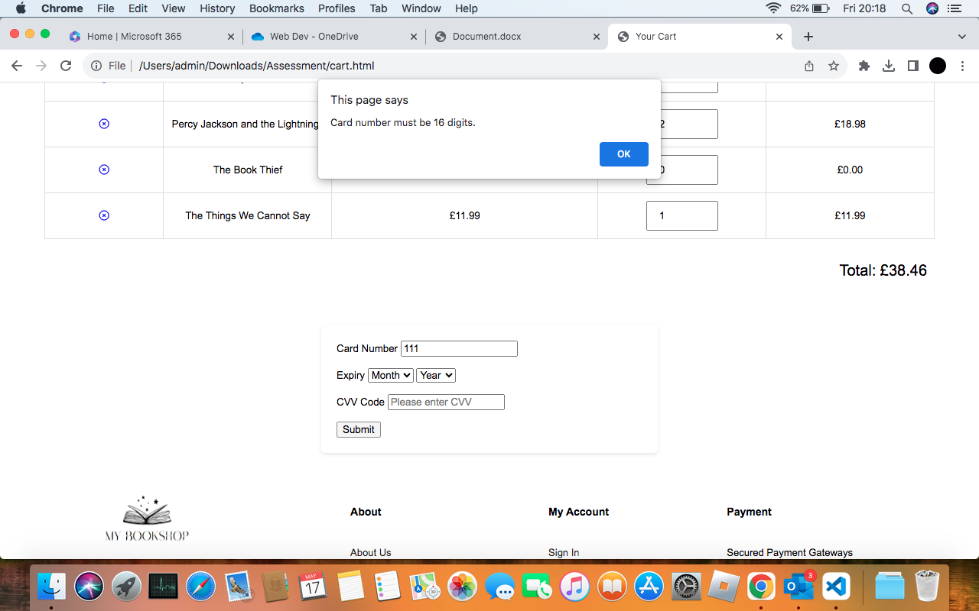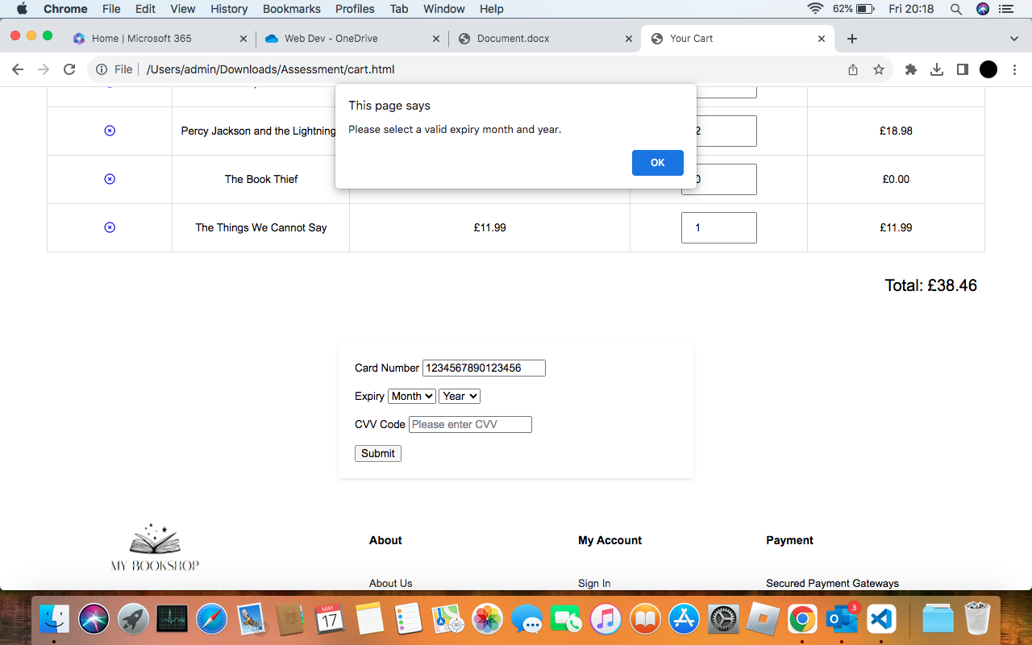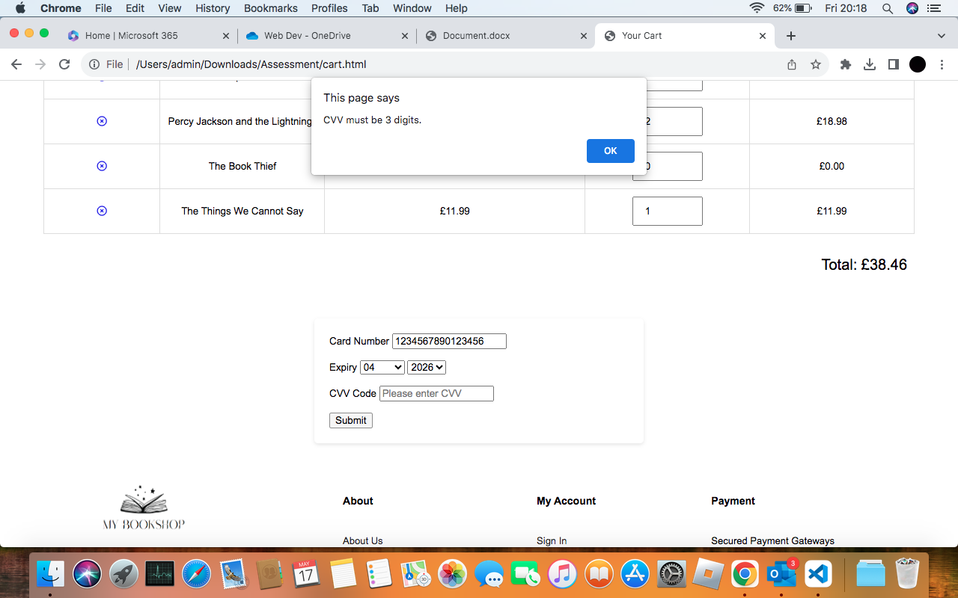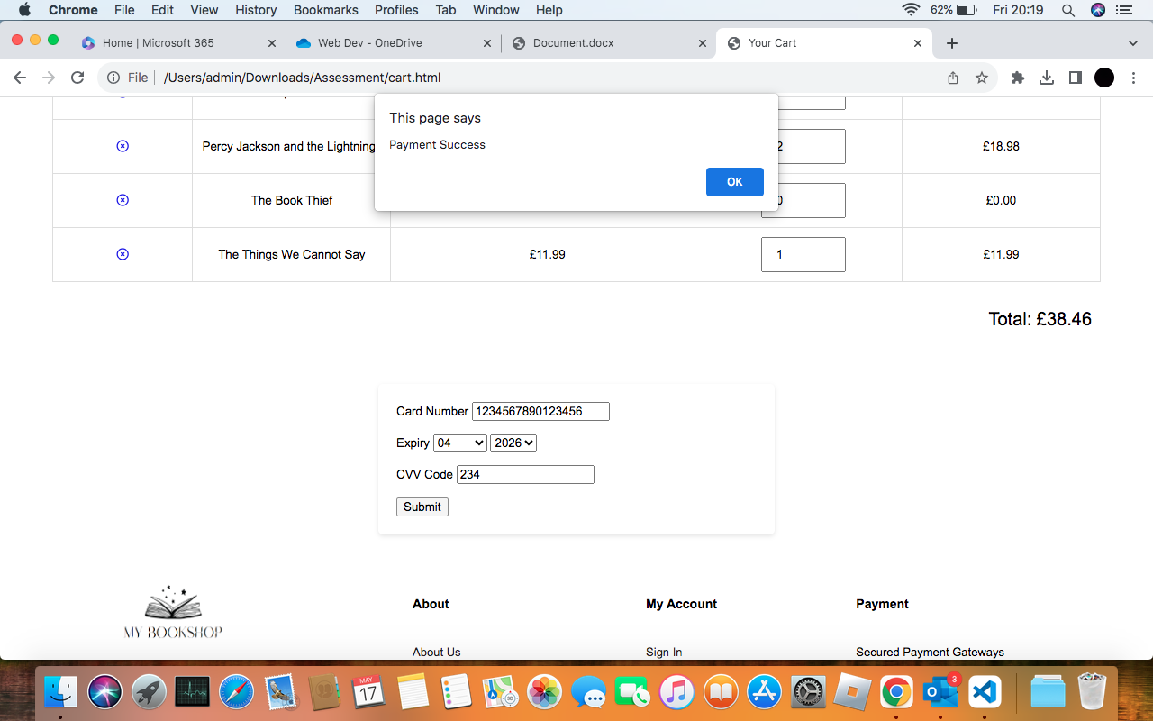

**Screenshots from mobile/tablet**

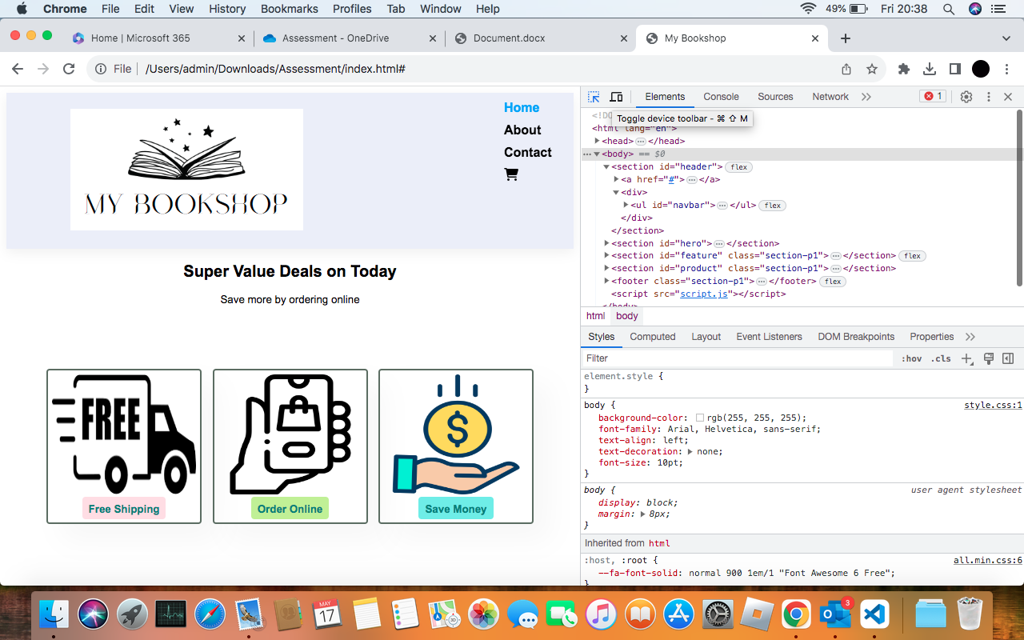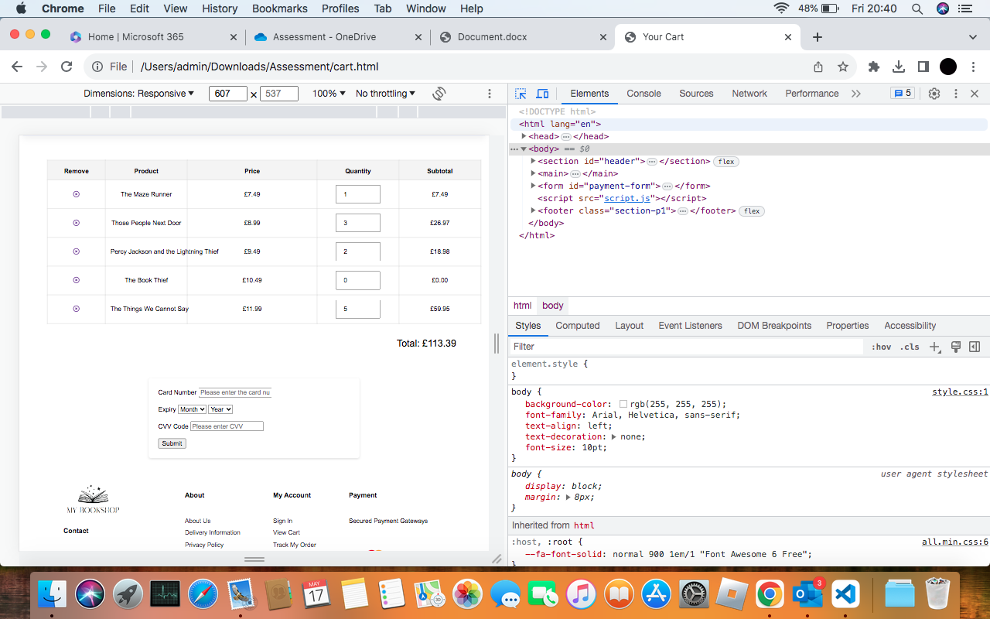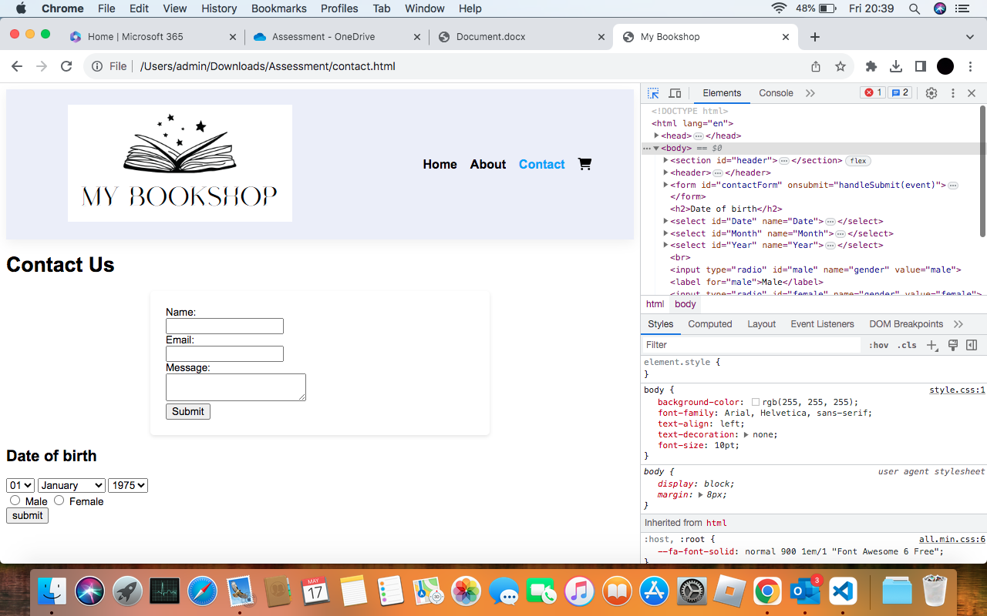

**Conclusion**

This is not my first time creating a html webpage, however, is it the first-time using JavaScript and CSS. Attending the labs and completing the worksheets made this task fairly easy. I didn't struggle with any of the design, but I did with the java and CSS as I was new to this.

I still aim to keep this on my portfolio and make improvements in the future to this design.